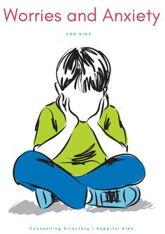
Managing my Child’s Anxiety
Is your child Anxious?

This group is for the parents of children 5-12 years,
who struggle with anxiety.
The Wellbeing Team are offering a 6 week group programme for parents to learn CBT-informed techniques they can implement in their home, or with their child to aid them in managing their anxiety.
This is a chance for parents to share their experiences, and to learn ways to help their child manage their difficult emotions.

Spaces are limited, so if you are interested, please let your early help advisor know.

Aims of the programme
- Increase understanding of anxiety
- Maintenance of anxiety, including the role a parent plays in this, and how to break the cycle
- Physical response to anxiety
- Relaxation and breathing exercises
- Gradually facing the fear
- Coping with worry
- Problem Solving
- Mindfulness
- Thought Challenging
- Signposting to additional services

